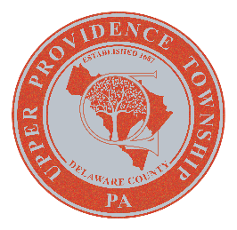

UPPER PROVIDENCE tOWNSHIP

DELAWARE COUNTY, PA

resolution 2025-19

WHEREAS, Upper Providence Township, Delaware County, hereby recognizes the week of May 18th through May 24th, 2025 as Public Works Week.

WHEREAS, our Public Works professionals serve this community every day by providing the following services:
- Repair to Township Streets
- Install and maintain regulatory and street signs
- Maintain over 400 storm sewer inlets and replace miles of storm sewer pipes
- Provide snow removal and salting on Township streets
- Clear downed trees on Township streets
- Provide park maintenance: mowing, removing trash, trailblazing, and installing/maintaining playground equipment
- Maintain a fleet of 6 trucks, a loader backhoe and all other equipment
- Clear out storm drains and inlets
- Maintain three buildings belonging to the Township
- Paint school crossings, no parking "X", stop sign lines, handicap parking, and Vascar lines for the police

WHREAS, these services could not be provided without the dedicated efforts of our public works professionals.

WHEREAS, we acknowledge that our Public Works Department is of vital importance to the health, safety and well-being of the residents of Upper Providence Township and urge all residents to pay tribute to those employees and recognize the contributions they make every day.

WHEREAS, many times, public works professionals will never meet those whose lives have been impacted because when things are going right, no one knows that public works is there. Yet, with or without fanfare, public works is ever present, working in the background to advance quality of life for all in the Township.

IN WITNESS THEREOF, I affix my hand and attach the seal of the Upper Providence Township, this 8th day of April 2025.

Upper Providence Township

BY:

Marsha Peterson

Council Chairperson

ATTEST:
Barry Luber
Township Secretary

