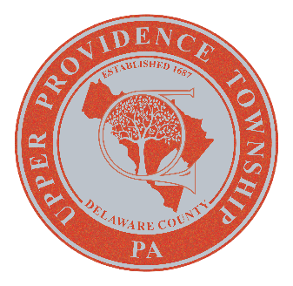


UPPER PROVIDENCE tOWNSHIP

DELAWARE COUNTY, PA

resolution 2025-18

WHEREAS, since the beginning of law enforcement within the Commonwealth, hundreds of police officers have made the ultimate sacrifice while in the line of duty; and

WHEREAS, these officers risk their lives every day to protect our communities, and their bravery and selfless services shall not be overlooked by a grateful nation; and

WHEREAS, across the United States, the week of May 11 through May 17, 2025, will be recognized as “National Police Week”; and

WHEREAS, the first “National Peace Officers’ Memorial Day” was held on May 15, 1982, following a proclamation signed by President John F. Kennedy on October 1, 1962, and has continued to be observed annually in memory of those police officers who made the ultimate sacrifice in the line of duty; and

WHEREAS, it has been resolved by the House of Representatives expressing support for recognizing “National Police Week” and unwavering support for law enforcement across the United States in the pursuit of preserving safe and secure communities; and

WHEREAS, Upper Providence Township, Delaware County, hereby honors the memory of the hundreds of police officers who have given their lives in the line of duty in this Commonwealth; and

NOW, THEREFORE, BE IT RESOLVED, the Upper Providence Township Council does hereby acknowledge May 11 through May 17, 2025, as National Police Week, and May 15, 2025 as Peace Officers Memorial Day in Pennsylvania.

IN WITNESS THEREOF, I affix my hand and attach the seal of the Upper Providence Township, this 8th day of April 2025.

Upper Providence Township Delaware County, Pa

BY:

Marsha Peterson - Council Chairperson

ATTEST:
Barry Luber - Township Secretary

