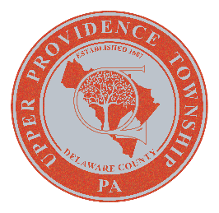

UPPER PROVIDENCE tOWNSHIP

DELAWARE COUNTY, PA

resolution 2025-17

A Resolution of Upper Providence Township, Delaware County, Pennsylvania, in observation of Local Government Week, April 14th through 18th, 2025.

Whereas, Upper Providence Township, Delaware County will be observing the week by reminding its residents and businesses of the critical role local government plays in their lives, and

Whereas, as local government, we must make sure our residents and businesses have access to the critical infrastructure they need to conduct their lives, including roads, bridges, water, sewer, trash collection, public safety, and safe, accessible roadways, and

Whereas, Upper Providence Township and the more than 1,400 other townships in the state have a primary responsibility in ensuring the community stays safe and secure through whatever challenges present themselves, and

Whereas, local government is established to be a direct reflection and representation of the people who live there, townships are places where residents have a voice in what happens and where services provided don’t exceed what the community needs or can afford, and

Now therefore Upper Providence Township Council celebrates the role of citizen participation in local government and encourages increased engagement in civic involvement by observing Pennsylvania Local Government Week on April 14-18, and

IN WITNESS THEREOF, I affix my hand and attach the seal of the Upper Providence Township, this 25th day of March, 2025.

Upper Providence Township

BY:

Marsha Peterson

Council Chairperson

ATTEST:
Barry Luber
Township Secretary

